****************************************** * Up work ******************************************************
- Project Visibility, Experience level, Project time & duration field remain blank.
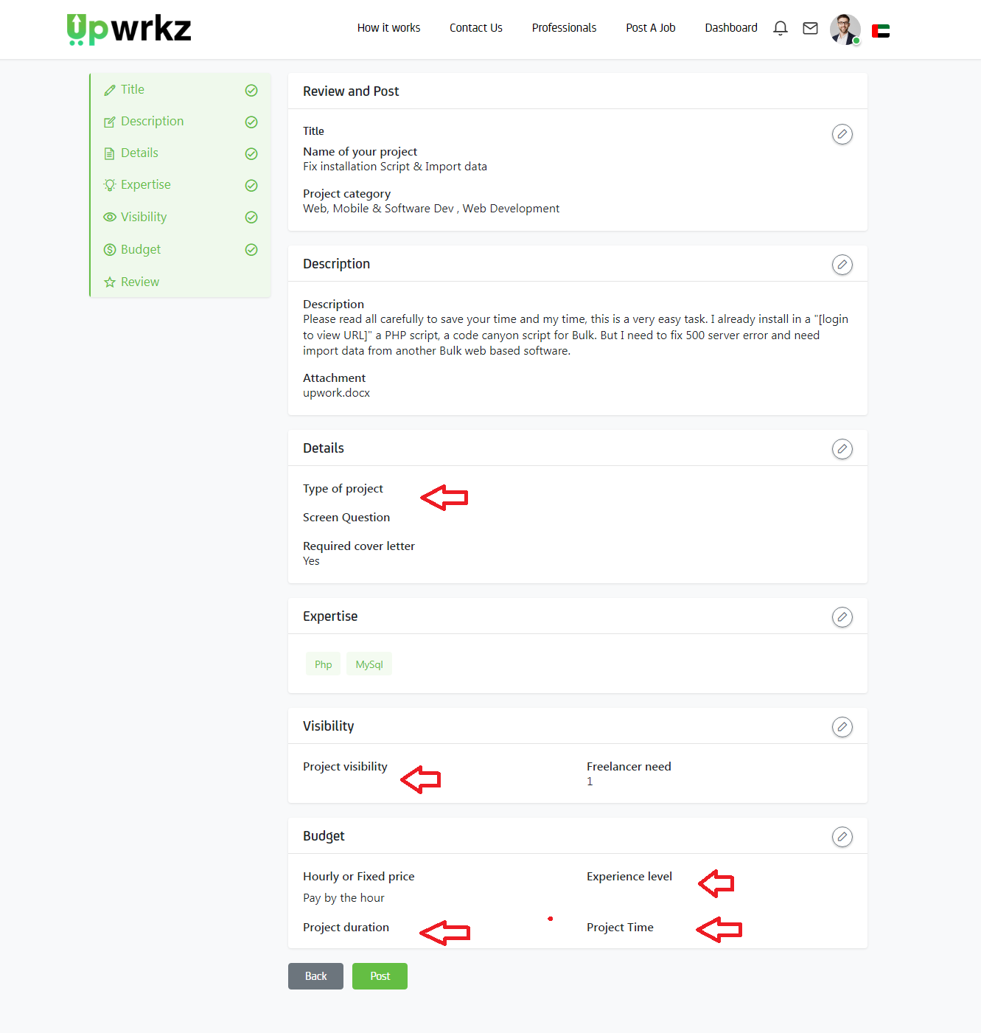

- https://upwork.scriptlisting.com/postproject/add (Text Should be remove & Box color should be green)

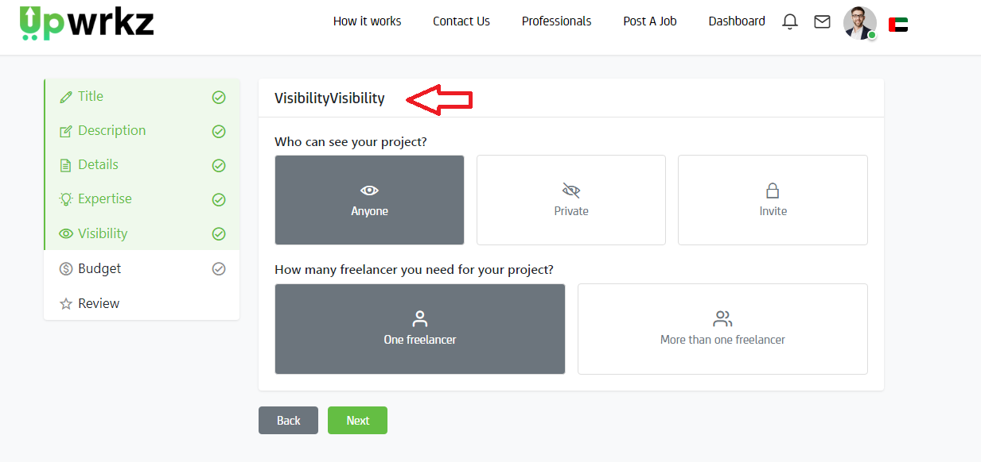

- https://upwork.scriptlisting.com/postproject/add (Field box color should be green)

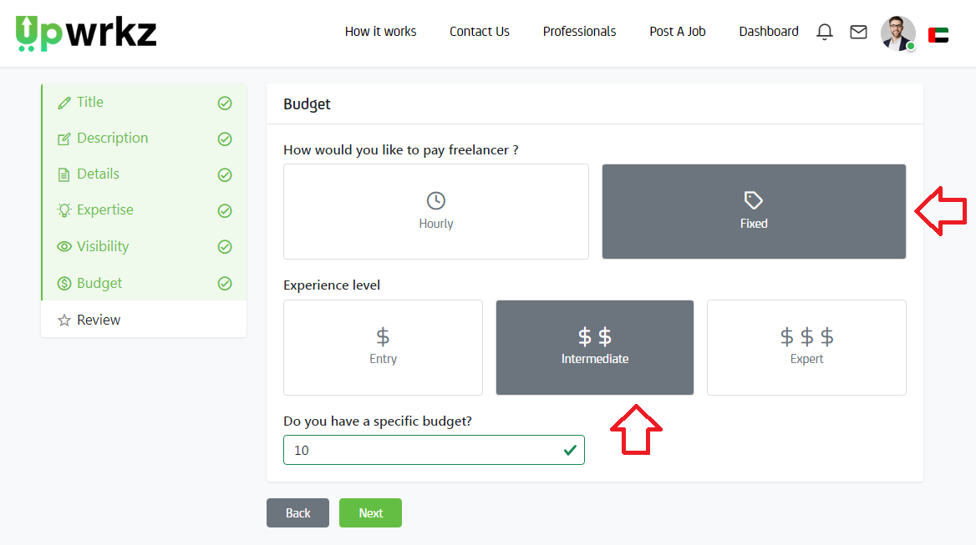
4)

